HOW TO EDIT ADDRESS OF SHAREHOLDERS FOR A PUBLIC COMPANY:
Since ASIC do not store information about the shareholders of a public company, lodging of a Form 484 is not necessary.
To update the address in Corporate Messenger, follow the steps below:
Step 1: Menu > Companies > Open the company profile
Step 2: Move from the main profile page to the share page
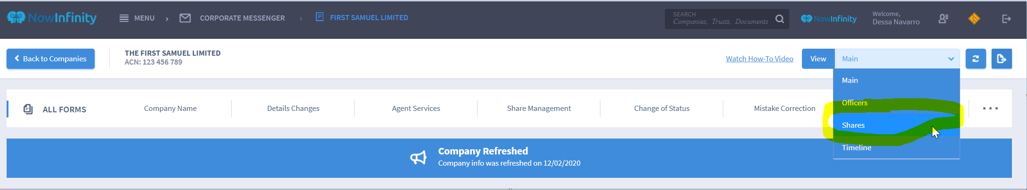
Step 3: Once you are in the shares page, go to the Allotments table and search for the shareholder that will need to have an address change
Step 4: Then click on the three dots and choose EDIT
Step 4: After choosing EDIT, you will get another page that will allow you to edit the address. Once done updating the address, click on the ADD button.
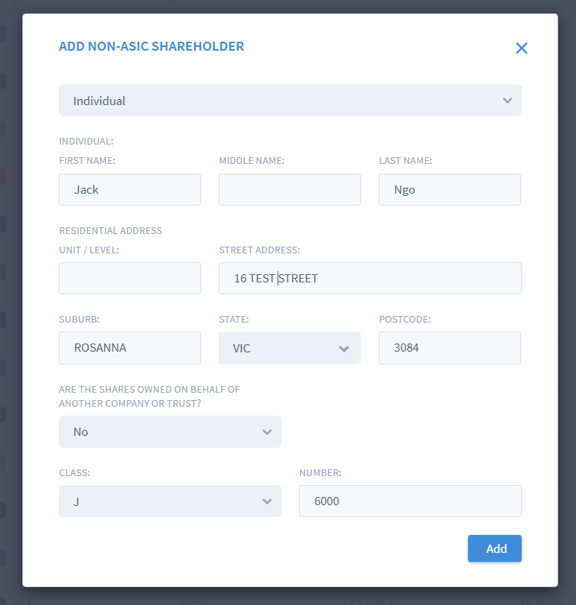

Step 5: Once All changes are completed, click on SAVE CHANGES at the bottom of the allotments page
